|  |  |  |
| --- | --- | --- |
| Unit 7 Written quiz | Name: ____Chhorn Sotheavann______ | **Total Score** |
| Date: _____08-02-2004____ | ______ /50 points |

A CD icon.tiff Listen to Andy and Kate talk about their anniversary. Circle the correct answer for each statement.

1. In the past, Andy and Kate ____went to a restaurant___ on their anniversary.

a. invited people to dinner b. went to a restaurant c. stayed home together

2. Andy and Kate very recently ____ moved to a new apartment___ .

a. held a potluck b. moved to a new apartment c. had friends over

3. For their anniversary dinner this year, Kate is going to make ____the salad ___ .

a. the main dish b. the side dishes c. the salad

4. The dessert is going to come from ___a bakery__ .

a. a guest b. Andy c. a bakery

**A** _______ /8 points (2 points each)

B Write answers to the questions. Use the underlined verbs and the words in parentheses.

**Example*:******A***Do you usually clean your car yourself?

*have it cleaned at a car wash*

***B***No, I always ____________________________________ . (have / at a car wash)

1. ***A***Have you ever fixed the plumbing in your house?

***B***No, I always _____get a plumber to fix it_____ . (get a plumber)

2. ***A***Have you ever changed the battery in your car?

***B***No, I always ____have it changed at a garage_____ . (have / at a garage)

3. ***A***Do you usually do your own laundry?

***B***No, I _____get it done at the laundromat____ . (get / at the laundromat)

4. ***A***Have you ever repaired your computer yourself?

***B***No, I always _______have it repaired by a professional_____ . (have / by a professional)

5. ***A***Do you ever cut your own hair?

***B***No, I always _____have a hairdresser cut it_____ . (have a hairdresser)

**B** _______ /10 points (2 points each)

C Complete each conversation. Choose the correct response from the box. Rewrite the sentences as “shorter sentences.” There is one extra response.

I’d like some eggs. Have you got enough money?

I’d love to. Is that movie still playing?

No, I’m not. I’m just learning how to use it.

OK. Do you want me to find some music?

Sure. Do you think we should get there early?

1. ***A***Having problems with your camera? 3.***A***I’m going to the store. Need anything?

***B*** *___No I’m not. I’m just learning how to use it____* ***B*** *_I’d like some eggs. Have you got enough money?__*

2. ***A***Could you turn on the radio, please? 4.***A***Want to go out this weekend?

***B*** *___Ok. Do you want me to find some music?____* ***B*** *__I’d love to. Is that movie still playing?___*

**C** _______ /8 points (2 points each)

D Complete the sentences in two ways. Use *need* and the verbs in parentheses.

*needs to be upgraded*

**Example:**My computer is slow. It probably ____________________________________ .

*needs upgrading*

OR It ____________________________________ . (upgrade)

1. The clock stopped. The battery probably ____needs to be replaced_____ .

OR It _____need replacing____ . (replace)

1. The screws on the doorknob are loose. They _____need to be tightened_____ .

OR They ______need tightening_____ . (tighten)

1. Can you take the car to the garage? The oil _____needs to be changed______ .

OR It _____needs changing____ . (change)

1. The picture on the TV is weird. The color ______needs to be adjusted_____ .

OR It _____needs adjusting______ . (adjust)

1. The pipes are leaking. They _____need to be fixed_____ .

OR They _____need fixing_____ . (fix)

**D** _______ /10 points (1 point each)

E Circle the correct words to complete the sentences.

1. Listen to the refrigerator. It’s **got a shock / torn / making a funny noise**.

2. I left the lights on in the car. The battery is probably **slow / dead / loose** by now.

3. The living room rug is in bad shape. It’s covered with dark **holes / dents / stains**.

4. The oven door **is falling off / won’t turn on / keeps flickering**.

**E** _______ /4 points (1 point each)

F Read the article. Add the missing sentences. Write the letters in the blanks. There is one extra sentence.

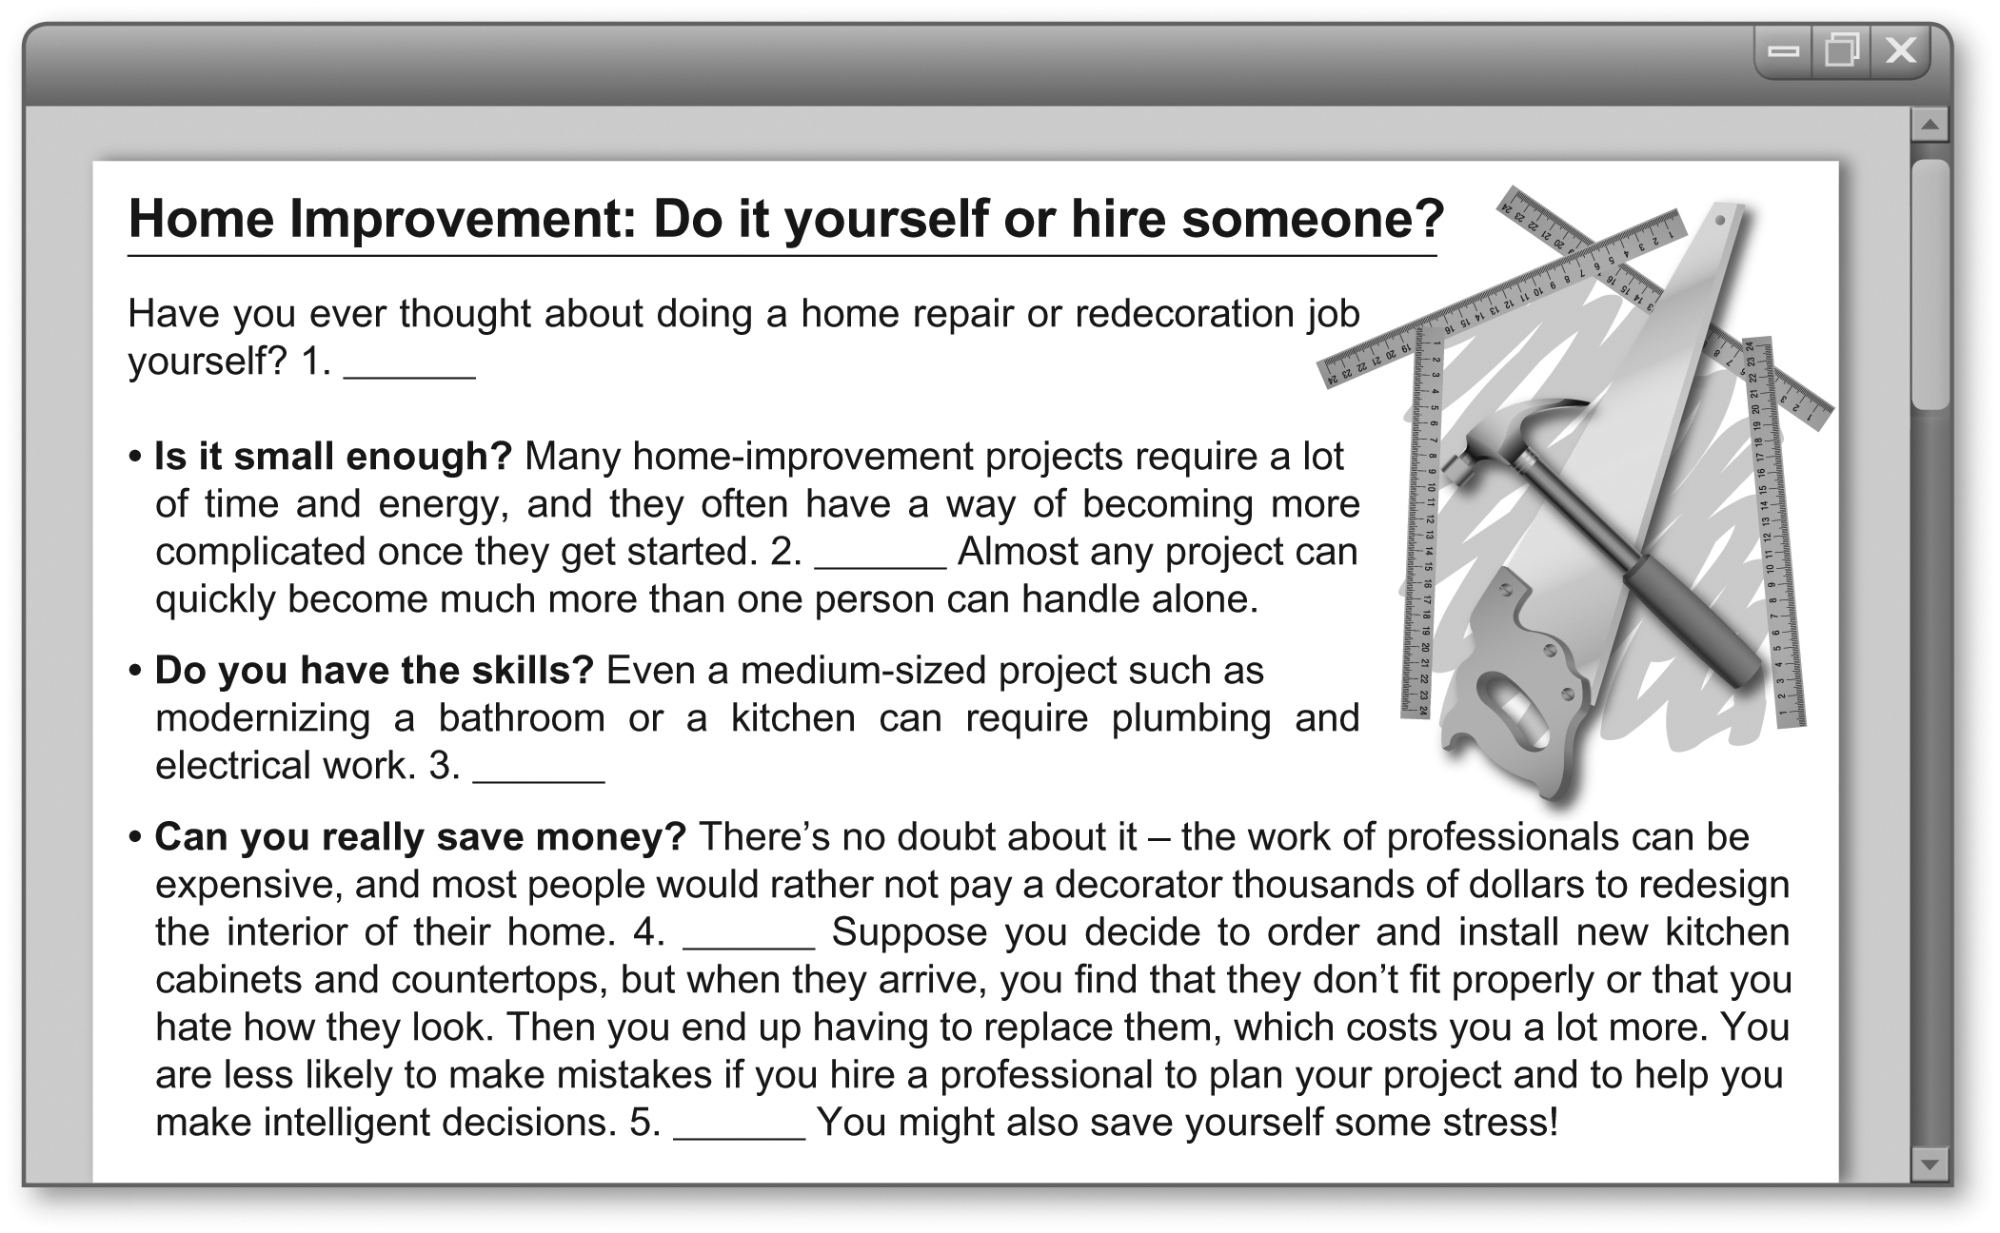

b

c

a

d

f

a. If you don’t already have experience in these specialized areas, you should get a professional to do the work

for you.

b. In the end, this kind of expert help can actually save you money.

c. On the other hand, home-improvement mistakes can also be very expensive.

d. For example, maybe you plan to paint one or two rooms, but then realize that the whole house needs a fresh coat

of paint!

e. You shouldn’t look for a bargain when hiring a professional to do the work.

f. Experts say that people thinking about taking on a home-improvement project by themselves should first consider

three basic questions.

**F** _______ /10 points (2 points each)